**FFSD**

**­­­­Fundaments of Full Stack Development**

**LTPC:- 2-1-1-4**

**Lec-1 : 06.01.2022**

**Couse Objective:**

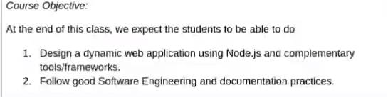

**Course Plan:**

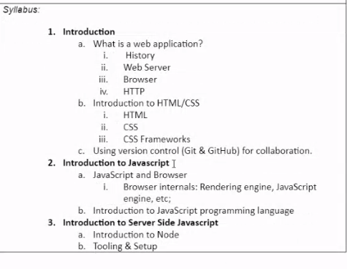

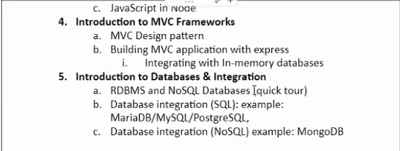

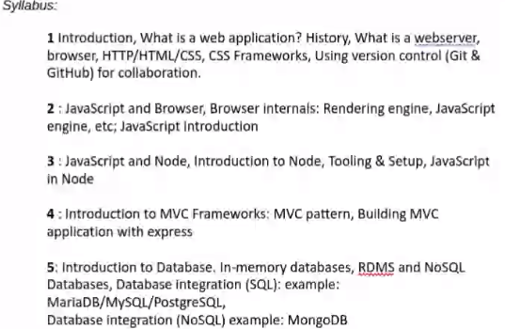

**Unit 1 - Bheem sir**

**Unit 2&3 – Subbu sir**

**Unit 3,4 – Himangshu sir**

